Utah Statewide Archaeological Society Convention
June 14-15 2013
Provo, Utah
Brigham Young University

Hosted by: Museum of Peoples and Cultures, BYU
Department of Anthropology, BYU
Office of Public Archaeology, BYU
Manti-La Sal National Forest
Utah County Chapter of USAS

Conference Schedule

Special Note: Families are welcome at this event! Parental supervision at workshops is required for children under 12. You will all learn new things about Utah’s fascinating past.

Pre-Conference Volunteer Opportunity!

Thursday, June 13 – Volunteer at Wolf Village with the BYU Archaeological Field School for
half or all of the day. The site is a large village located near the south end of Utah Valley. Please sign up ahead of time by contacting Kari Nelson or Elizabeth Smith at 801- 422-0022 or mpc_programs@byu.edu. They will also send you a map to the site and more information on what to bring when you come to excavate.

Conference Events
Friday, June 14

9 am to 5 pm (Lunch is on your own)

Registration: BYU Museum of Peoples and Cultures (see the attached map)

9 am – 5 pm

Museum Tours / Volunteer Opportunities: Museum of Peoples and Cultures

9 am – 5 pm
See artifacts from: The Old Provo Tabernacle and the Parowan Valley
Wash artifacts from: Site 13 (Alkali Ridge) and Wolf Village
Sort artifacts from: Cave Canyon Village, Montezuma Canyon
Learn about: Historic document/photo scanning and archiving

Friday, June 14 (continued)

Wolf Village Excavation Tours: Wolf Village (Fremont village in the south end of Utah
Valley; maps will be included in your registration packet)

Tours begin at 10 am, 11 am, 1 pm and 2 pm

Lake Mountain Rock Art Tours: See intriguing and endangered rock art west of Utah
Lake with BLM archaeologists. Get maps and details at Registration.

Self-guided Tours: Camp Floyd State Park, Hutchings Museum, BYU Museum of Art

6 to 8:30 pm

Registration: 5 – 8:30 pm Room 3228, Wilkinson Center (WSC), BYU
(see attached maps for BYU and the Wilkinson Center)

Welcome and Dinner: 6 – 7 pm Room 3228, Wilkinson Center, BYU

Speakers: 7 – 8:30 pm Room 3228, Wilkinson Center, BYU

“Household Variation, Public Architecture and the Origins of Fremont Communities” – Katie Richards, Graduate Student, Department of Anthropology

“The Archaeology of the Archaeology of Provo” – Adrien Mooney, Graduate Student, Department of Anthropology

“Corn and Climate in the Fremont World” – Dr. James R. Allison, Professor, Department of Anthropology

“The Parowan Valley Archaeological Project” – Sara Stauffer, Manti-La Sal National Forest

Saturday, June 15

9 am to 4 pm (Lunch on your own)

Registration: Room 3221, Wilkinson Center, BYU

One-Hour Long, Hands-on Workshops: Rooms 3221, 3223, 3250, Wilkinson Center

There will be concurrent sessions, with several taught more than one time. A final workshop schedule will be in your registration packet.

How to be a Consulting Party on Development Projects: Lori Hunsaker, Deputy
Utah State Historic Preservation Officer, Utah State History

Fremont Ceramics: Lane D. Richens, Office of Public Archaeology

Saturday, June 15 (continued)

Teaching Archaeology to Kids – Education at the MPC: Kari Nelson, Education
Curator, Museum of Peoples and Cultures

Chipped Stone Identification: TBA

Animal Bone Identification: Sara Stauffer, Manti-La Sal National Forest

Kayenta and Virgin Ceramics: Dr. Jim Allison, Department of Anthropology,
BYU

How to Identify Human Bone and What to Do if You Find Human Bone:
Derinna Kopp, Physical Anthropologist, Utah State History

Historic Artifacts: Deb Harris, Office of Public Archaeology, BYU

Mesa Verde Ceramics: Charmaine Thompson, Manti-La Sal NF and Dr. Allison

Advances in Mapping Technology: Scott Ure, Department of Anthropology,
BYU

5 to 6 pm Room 3223, Wilkinson Center, BYU

USAS Business Meeting

6 to 7 pm Room 3228, Wilkinson Center, BYU

Banquet and Awards

7 to 8 pm Room 3228, Wilkinson Center, BYU

Keynote Address: “Archaeology in the Public Square: The Original Provo Tabernacle Project” – Richard K. Talbot, Director, Office of Public Archaeology, BYU

Learn about the history of the first Pioneer-era public building in Utah County and the large-scale excavation project that brought this massive building and the people who used it back to light.

Maps and General Information
Museum of Peoples and Cultures, Brigham Young University

Located at 700 North 100 East, Provo

Parking is available across the street to the east.

For more information call 801-422-0020 or visit https://mpc.byu.edu

BYU Museum of Peoples and Cultures

Maps and General Information
Camp Floyd/Stagecoach Inn State Park and Museum

18035 West 1540 North
Fairfield, UT 84013
801-768-8932
From I-15; take the Lehi exit #279, which is Lehi's Main Street. Continue west along this street, which eventually turns into Hwy 73. Continue along this highway to the town of Fairfield, approximately 22 miles from Lehi. Once in Fairfield, follow the highway signs to the park.

Hutchings Museum of Natural and Cultural History
55 N. Center St. Lehi, Utah 84043
801-768-7180
BYU Campus

PLEASE NOTE CONSTRUCTION DETOURS: BYU is rebuilding the parking area east of the Wilkinson Center and Provo is putting a water pipe under 900 East.

To access free visitor parking east of the Wilkinson Center from University Avenue, go east on 700 North. Turn north (left) at the stoplight at 700 East. Go about 2 blocks north to a “T” intersection; turn east (right) and go about half a block to a stoplight at East Campus Drive. Turn north (left) and go about 2 blocks north to 1060 North (and a stoplight). Turn right and then immediately left into the visitor parking lot. The Wilkinson Center is to your west from here.

To access free visitor parking north of the Museum of Art from University Avenue, go east on 1230 North. The road climbs up a bench to a stoplight; continue east and under a pedestrian walkway. Turn right into a visitor parking lot at the Museum of Art (it’s the driveway with the little security building next it). Park and take the sidewalk west of the Museum, walk south past the big Harris Fine Arts Center Building. The Wilkinson Center is the next building on your left; the Bookstore is in the west end of the Wilkinson Center.

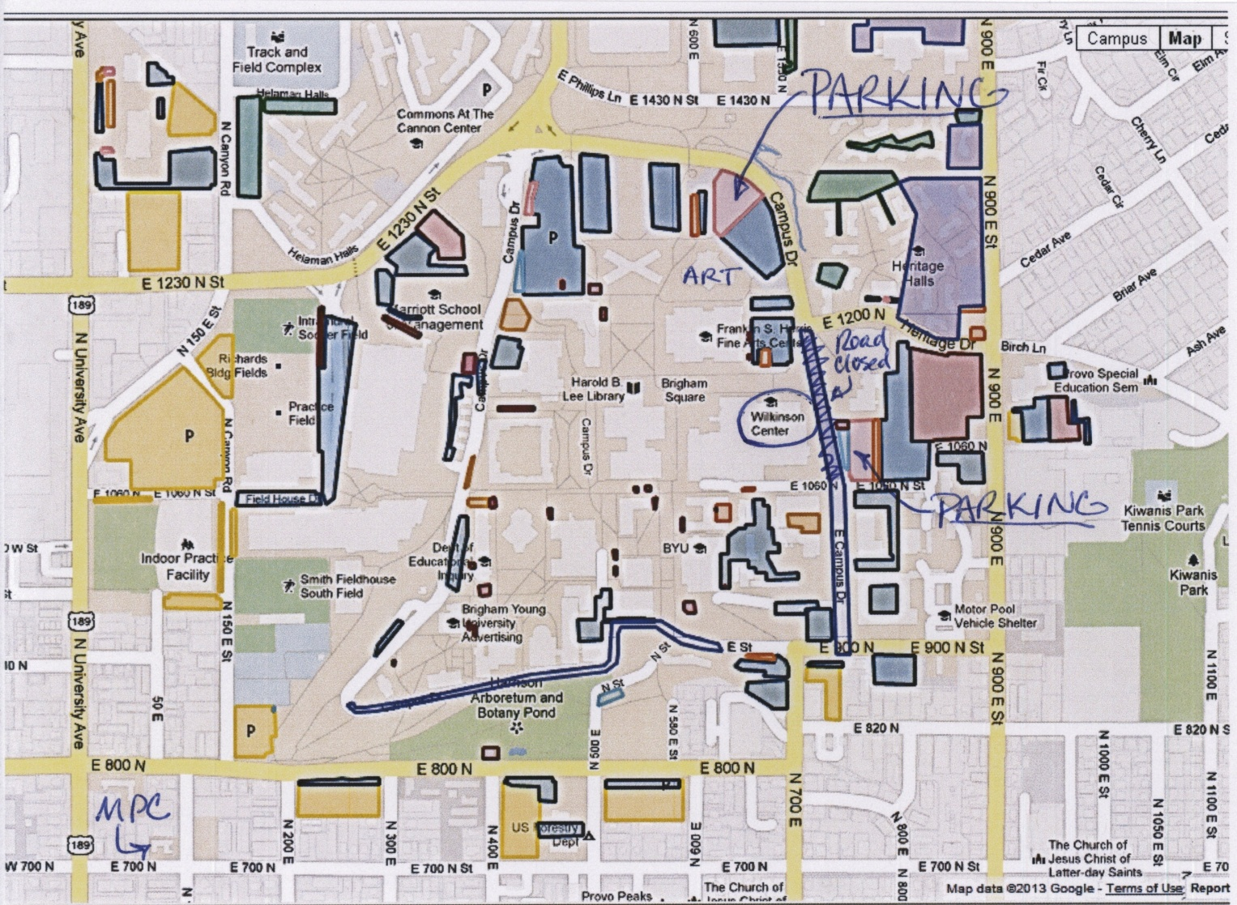

BYU Wilkinson Student Center
Once inside the Wilkinson Center, there are several stairways and elevators that get you to the second floor. We are meeting on the second floor in rooms located just south of the big two-story open space in the center of the building that is adjacent to the Cougareat Food Court.

Red arrows direct you to the meeting rooms.

Utah Statewide Archaeological Society Convention
June 14-15 2013
Provo, Utah
Brigham Young University

Registration Form

Name(s):______________________________________________________________________

Address:______________________________________________________________________

City:_________________________ State:_____________________ Zip Code:_____________

Phone #:________________________ Email:________________________________________

USAS Chapter:___________________________________________

Cost Number of People Total

Early Conference Registration $ 10.00 x _____________ = ____________

On-site Registration $ 15.00 x _____________ = ____________

Early Family Registration $ 25.00 x _____________ = ____________

On-site Family Registration $ 30.00 x _____________ = ____________

Friday Night Dinner $ 10.00 x _____________ = ____________

Saturday Night Banquet $ 18.00 x _____________ = ____________

Total Amount Enclosed ____________

- Please check this box if you would like vegetarian meals
Please tell us if you have other dietary needs:__________________________________________

Please make checks payable to: Utah County Chapter USAS

Please mail your registration to: Toni Wall
2105 Powerhouse Road, Spanish Fork, UT 84660

If you have any questions, feel free to contact: Kari Nelson or Elizabeth Smith
801-422-0022
mpc_programs@byu.edu

Meal orders and registration need to be received by June 8.

Registration Form (continued)

Please vote on the SIX workshops you’d most like to attend!

Just put a check mark or X next to the ones you pick.

We plan to have at least two sessions of the most popular workshops available. Your vote will help us schedule enough of the high-demand workshops for everyone to attend, but still keep workshop sizes small enough for lots of hands-on interaction.

- How to be a Consulting Party on Development Projects: Lori Hunsaker, Deputy
Utah State Historic Preservation Officer, Utah State History

- Fremont Ceramics: Lane D. Richens, Office of Public Archaeology, BYU

- Teaching Archaeology to Kids – Education at the MPC: Kari Nelson, Education
Curator, Museum of Peoples and Cultures, BYU

- Chipped Stone Identification: TBA

- Animal Bone Identification: Sara Stauffer, Manti-La Sal National Forest

- Kayenta and Virgin Ceramics: Dr. Jim Allison, Department of Anthropology, BYU

- How to Identify Human Bone and What to Do if You Find Human Bone:
Derinna Kopp, Physical Anthropologist, Utah State History

- Historic Artifacts (including artifacts from the Old Provo Tabernacle): Deb Harris, Office of Public Archaeology, BYU

- Mesa Verde Ceramics: Charmaine Thompson, Manti-La Sal NF and Dr. Allison, BYU

- Advances in Mapping Technology (including aerial mapping with drone airplanes): Scott Ure, Department of Anthropology

